***Empowering the Farmers Incorporation***



***Mission:***

**United States of America based not-for-profit 501(c)(3)**, EIN# 93-2644193 **“Empowering the Farmers Incorporation”** provides humanitarian aid which includes bulls, tractors, crops, generators, mills, and other farming needs to produce essential foods to those affected by the war in Tigray.

***History:***

Tigray, the Northern part of Ethiopia, has been experiencing harsh conditions since November 2020 with a war and the consequent famine or equivalent conditions of food emergency.

Farming is the main source of Tigray’s economy with over 90% of the population being farmers. In Tigray, the farmers till their land with oxen-drawn plows cultivating predominantly cereal corps. The war forced most of the farmers to be internally displaced while some fled to the neighboring Sudan becoming refugees. During the war the enemies’ forces pillaged their homes, looting essential items, farm tools, burned their corps, ploughs, and slaughter their animals. Consequently, their land was left without fertilizer. As a result, the Tigrayan farmers and their families have been facing never-ending loss of lives, hardships, and severe and chronic malnourishment to mention a few affecting 5.2 million people. Post-war, they face a more severe drought than before due to lack of farming tools (includes sickle, pickaxe, plough shaft, ploughshare, plow, beam, and animal force) oxen, fertilizer, seeds, or manpower. The Tigray people endure daily hardships that includes battling hunger, thirst, and various diseases. Millions were displaced with no access to basic water and food supplies.

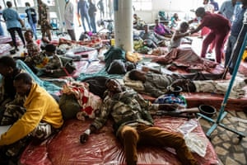

“Tigray submitted to a blockade with all telecommunication and lifelines to the outside world cut (1) a blockade that continued into 2022. The near absence of economic activities, combined with limited food stocks and restricted humanitarian access, resulted in at least 70% of the population experiencing starvation (2) i.e., high levels of acute food insecurity and excess mortality (3 (4) .

UNICEF spokesman James Elder told reporters in Geneva that the region is on the brink of famine, adding that, without immediate assistance, Tigray will face a crisis not seen in a decade. “We are seeing more and more young children and babies slide dangerously close to sickness and potential death from malnutrition, so we have rung alarm bells and alarm bells are here we are now,” he said. “We now have the largest number of people classified as food-insecure in a decade since Somalia. And, as I say that, there is the very real risk of deaths of tens of thousands of children” (5).

In April 2023, the Untied Nations’ World Food Program (WFP) announced that it would temporarily suspend food aid in Tigray. The decision came amid reports of food misappropriations. Dozens of people queue inside a humanitarian aid center in Tigray to receive soup to treat child malnutrition. Tigray, one of the bloodiest wars of the 21st century, has left at least 600,000 dead in two years, and now civilians continue to starve due to food scarcity (6).

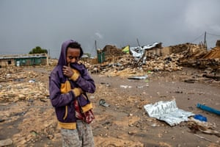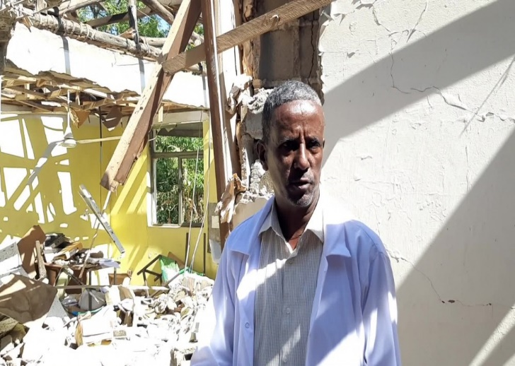

***Vision:***

Through your generous donations, Empowering the Farmers Inc. will deliver agriculturalists with bulls, tractors, crops, generators, mills and other farming needs to produce essential foods. Through our nonprofit organization, by collaborating with other Non-Governmental Organizations (NGOs) and local organizations, we will empower the communit~~i~~es of Tigray to rebuild their strength, wealth, and resources bettering the lives ofthose affected by the War.

Empowering the Farmers Inc. will assist growers to replace the labor-intensive traditional farming with modern farming techniques using modern technology without sacrificing the quality of their produces while increasing their productivity. For instance, by investing on rainwater harvesting techniques, farmers can farm all year round without having to rely on the weather. They could easily grow fruits and vegetables all year-round while protecting their crops against droughts, floods, and other weather-related factors.

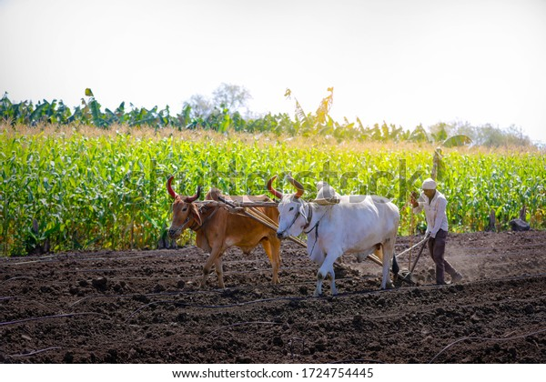

***Transparency and accountability:***

Empowering the Farmers Inc. works to ensure that its resources reach poor people in the most effective, efficient and transparency way. We are committed to promoting and adhering to the highest standards of accountability in our work and through our funding. Promoting efficiency through monitoring increased transparency encourages more careful monitoring and leads to higher-quality data, which in turn results in more effective use of resource.

***Transparency and financial disclosure:***

Every year Empowering the Farmers Inc. staff must declare their renewed commitment to the code of conduct, which provides guidance, among other things, on how to avoid conflict of interests.

**This United States of America based not-for-profit 501(c)(3),** EIN# 93-2644193 **“Empowering the Farmers Inc.” accepts all donations and is 100% tax deductible.**

Please donate to this Man-Made Famine victims in Tigray!



Ways to donate:

Zelle: [Empoweringthefarmers2024@gmail.com](mailto:Empoweringthefarmers2024@gmail.com)

Facebook, Instagram, YouTube, twitter (X)

Together we can achieve more!!

**Let’s save one farmer at a time.**



References.

1. let [2021](https://link.springer.com/article/10.1007/s13593-022-00812-5#ref-CR82); Gayim [2021](https://link.springer.com/article/10.1007/s13593-022-00812-5#ref-CR39); Ramos [2021](https://link.springer.com/article/10.1007/s13593-022-00812-5#ref-CR86)),
2. sensu Stratton et al. [2003](https://link.springer.com/article/10.1007/s13593-022-00812-5#ref-CR97)
3. Plaut [2021](https://link.springer.com/article/10.1007/s13593-022-00812-5#ref-CR84); Istratii [2021](https://link.springer.com/article/10.1007/s13593-022-00812-5#ref-CR55); Weldemichel [2021](https://link.springer.com/article/10.1007/s13593-022-00812-5#ref-CR116)
4. Oxford Analytica [2021](https://link.springer.com/article/10.1007/s13593-022-00812-5#ref-CR79); Devi [2021](https://link.springer.com/article/10.1007/s13593-022-00812-5#ref-CR29); Müller and Read [2021](https://link.springer.com/article/10.1007/s13593-022-00812-5#ref-CR69)
5. <https://addisstandard.com/news-under-five-children-dying-of-acute-malnutrition-in-tigray-sharply-increasing-amid-dire-humanitarina-crisis/>
6. <https://www.forbes.com/sites/ewelinachab/2023-09/02/over-1400-people-starved-to-death-in-tigray-since-food-aid-suspension/?sh=5b79a15d4873>